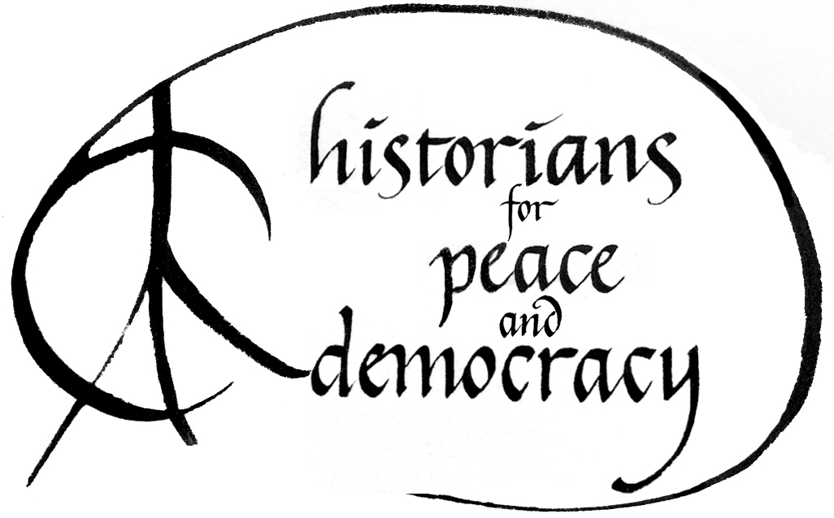

MARHO: The Radical Historians Organization

and

Historians for Peace and Democracy

*Invite you to a public roundtable:*

**What Should Historians Do in a Time of Crisis?**

**Saturday, January 6, 2018 10:30 AM-12:00 PM**

**Roosevelt Room 4 (Marriott Wardman Park, Exhibition Level)**

Agenda will include:

A brief history of Historians Against the War and its transition to H-PAD;

What H-PAD has accomplished and the challenges we face;

How to get involved and how to get others involved;

Plans and goals for the upcoming period.

For more information, contact H-PAD Chairs:

Van Gosse ([van.gosse@fandm.edu](mailto:van.gosse@fandm.edu)),

Margaret Power ([power@iit.edu](mailto:power@iit.edu)),

or Andor Skotnes ([skotna@sage.edu](mailto:skotna@sage.edu))