What’s the

Worst Thing

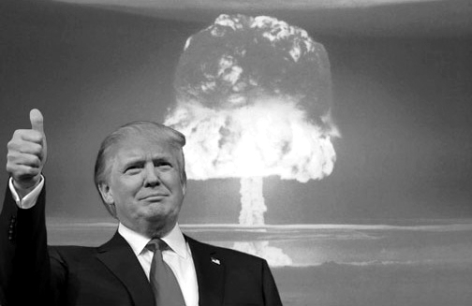Trump Could Do?

The threat of nuclear war with North Korea:

A [lecture/panel/discussion…]

[DATE & TIME]

[Location]

Sponsored by Historians for Peace and Democracy