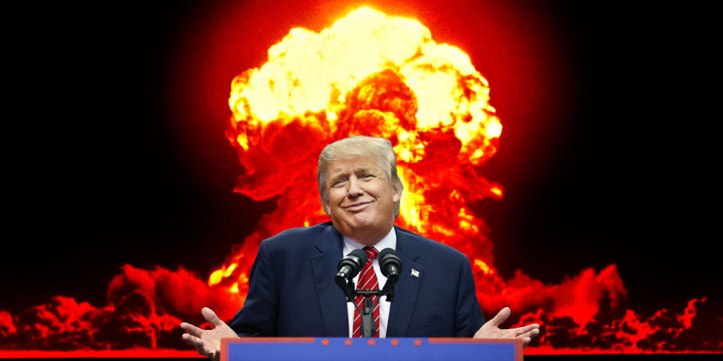
What’s the Worst Thing
Trump Could Do?
The threat of nuclear war with North Korea:
A [lecture/discussion…]

[DATE & TIME]
[Location]

Sponsored by

Historians for Peace and Democracy (historiansforpeace.org)

