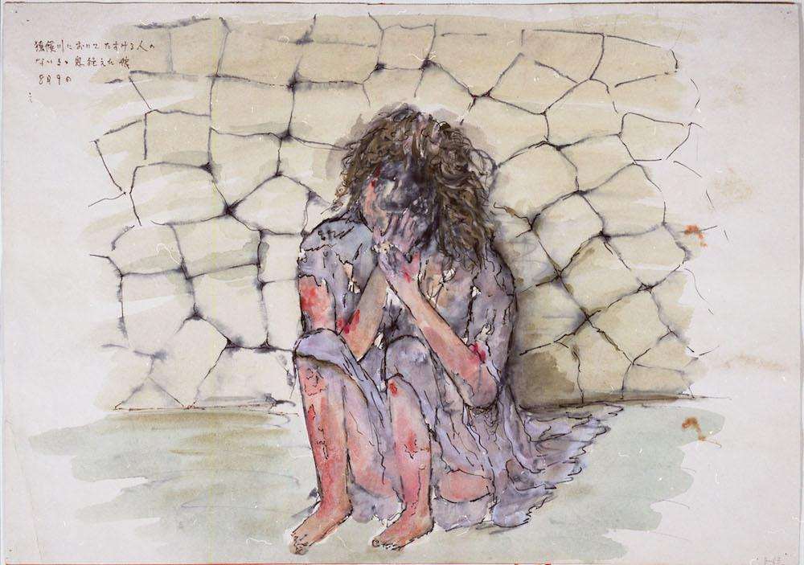
What’s the Worst Thing
Trump Could Do?
[DATE & TIME] [Location]

The threat of nuclear war with North Korea:
A [lecture/discussion/panel…]

Sponsored by Historians for Peace and Democracy

The above image is a painting by Masato Yamashita, a survivor of the U.S. nuclear bombing of Japan in 1945

