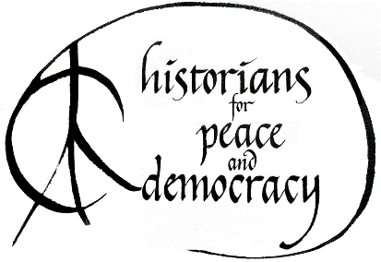 | H-PAD and HPAD-Related Activities  at the Annual Meeting of the American Historical Association  Friday & Saturday, January 5 & 6

1. Tabling for H-PAD at the AHA

H-PAD is sharing a table with MARHO/Radical History Review at the AHA, Friday, January 5, 11:30 to 2:30, in the atrium outside the Exhibit Hall in the Marriott Wardman Park. This table will be an excellent place to distribute H-PAD literature and to discuss H-PAD-related issues with interested conference-goers. It will also be a staging area for H-PAD folks to pick up flyers about our activities, and head out to distribute them widely throughout the conference areas.

Join us at the table for conversation and agitation!!!

2. Roundtable: A Fateful Misunderstanding: A Discussion of the Film Documentary “The Vietnam War” by Ken Burns and Lynn Novick.
The PBS documentary on the Vietnam War has already been viewed by millions of people and has received extraordinary publicity and attention This roundtable will consider some of the strengths and weaknesses of the series, and explore the continuing analytical issues that surround the Vietnam War on Saturday, January 6, 8:30 -10:00, Roosevelt Room 2 Exhibition Level, Marriott Wardman Park.
The chair is Michael Kazin, Georgetown University. The panelists are Christian G. Appy, Univ. of Massachusetts, Amherst; Mark Philip Bradley, University of Chicago; Heather Marie Stur, University of Southern Mississippi; Carolyn Eisenberg, Hofstra University.

3. “What Should Historians Do in a Time of Crisis?” H-PAD Public Roundtable at the 2018 Annual Meeting of the AHA
This roundtable is sponsored with MARHO: The Radical Historians Organization, Saturday, January 6, 10:30-12:00, Roosevelt Room 4, Exhibition Level, Washington Marriot Wardman Park.
The agenda will include:
- A brief history of Historians Against the War and its transition to H-PAD
- What H-PAD has accomplished, the challenges it faces, how to get more folks involved.
- Plans and goals for the upcoming period—most especially the effort, with other national groups, for teach-ins and educationals on the Korea crisis during the Winter Olympics in February.

Speakers will include H-PAD co-chairs Van Gosse, Margaret Power, Andor Skotnes

For more information, write the co-chairs at van.gosse@fandm.edu, power@iit.edu, or skotna@sage.edu
-Labor Donated-

